<https://learn.microsoft.com/en-us/power-bi/connect-data/service-aml-integrate>

* [Option B: Designer](https://learn.microsoft.com/en-us/azure/machine-learning/tutorial-power-bi-designer-model)

<https://learn.microsoft.com/en-us/azure/machine-learning/tutorial-power-bi-custom-model>

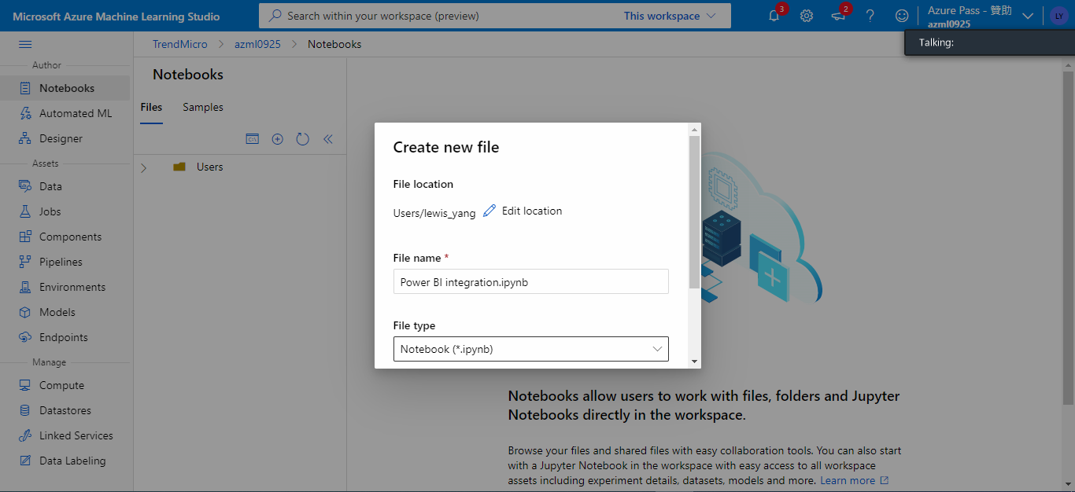

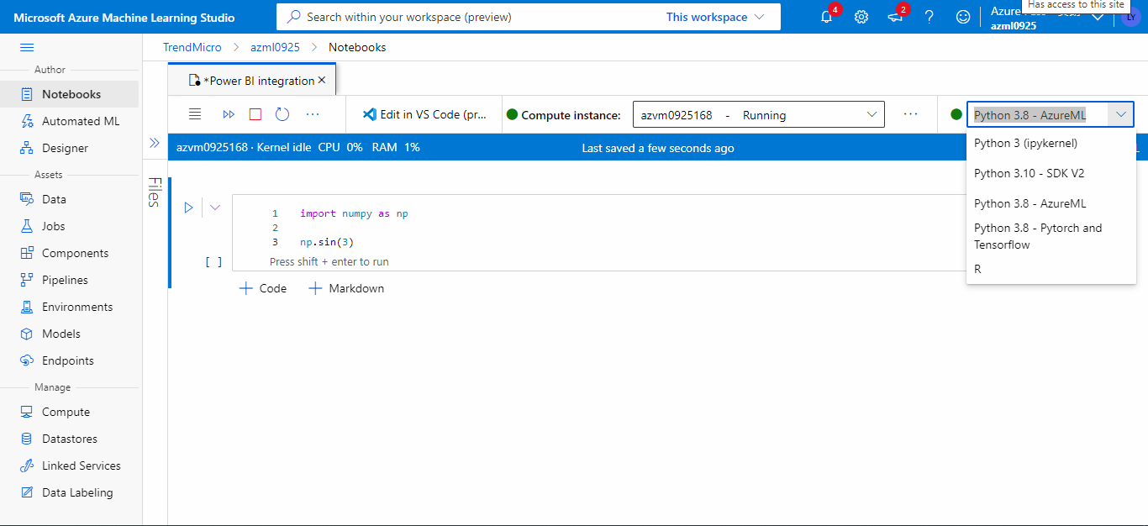

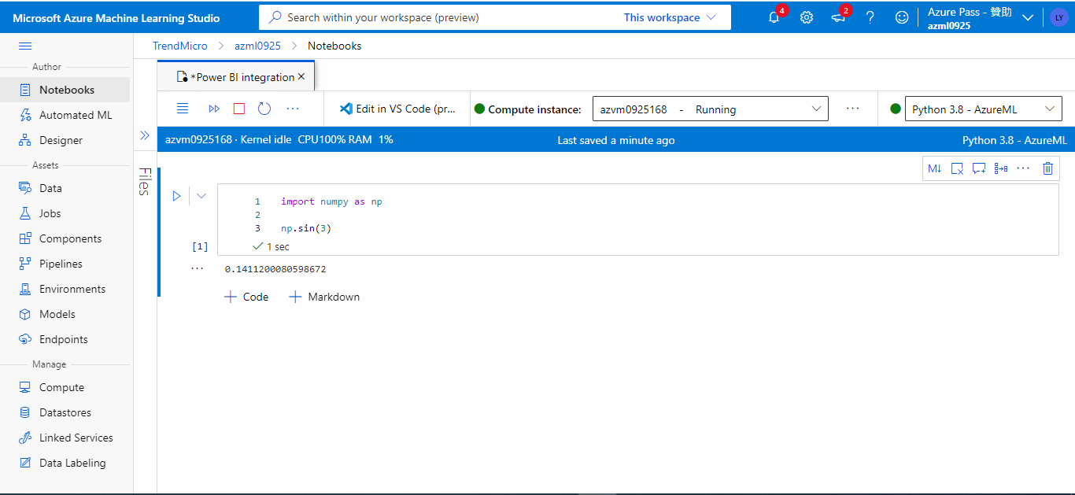

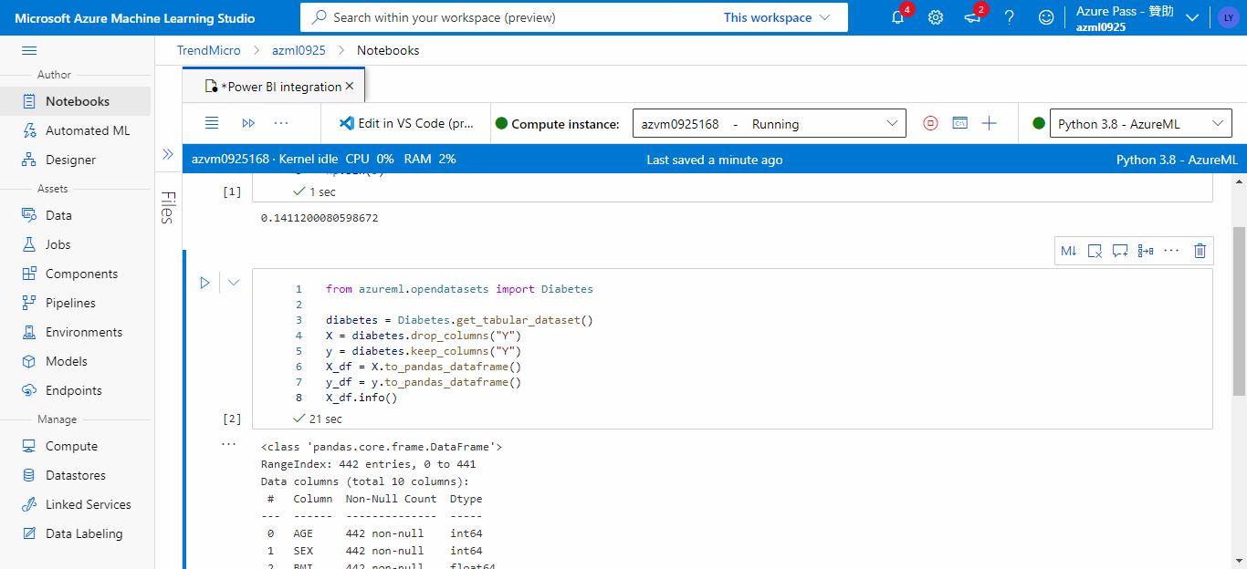

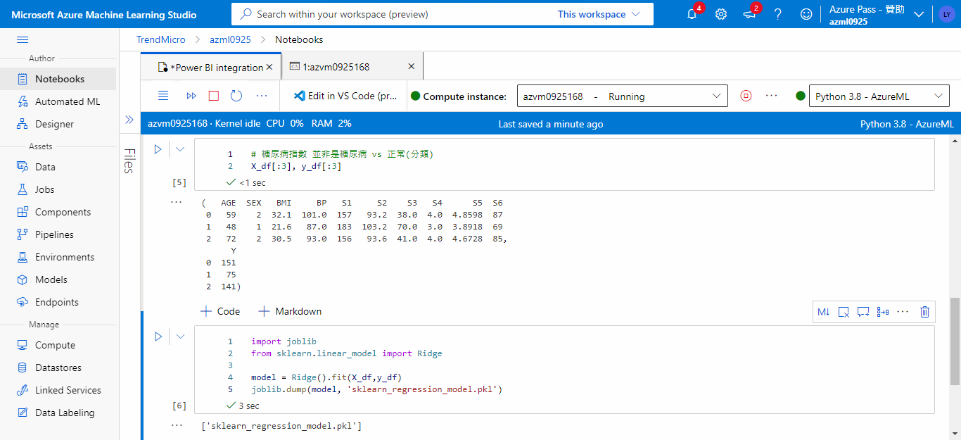

import joblib

from sklearn.linear_model import Ridge

model = Ridge().fit(X_df,y_df)

joblib.dump(model, 'sklearn_regression_model.pkl') # 輸出到哪裡?!

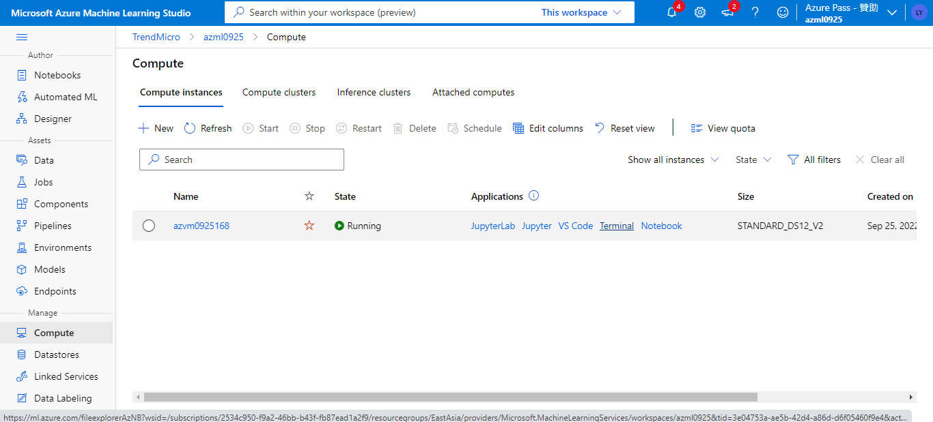

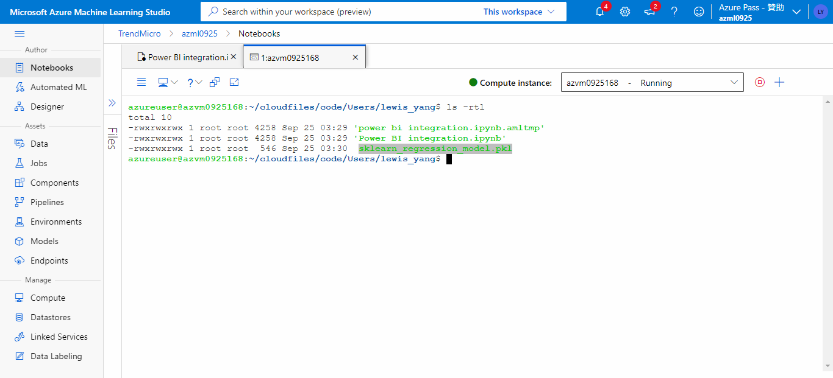

將上述MODEL從LINUX OS中進行註冊

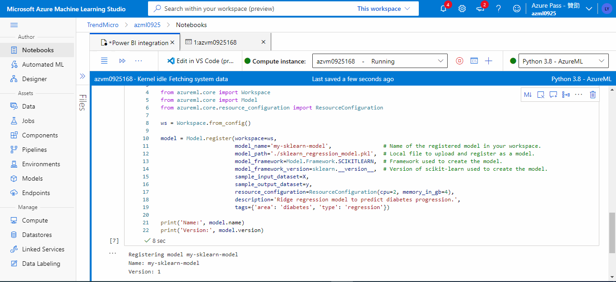

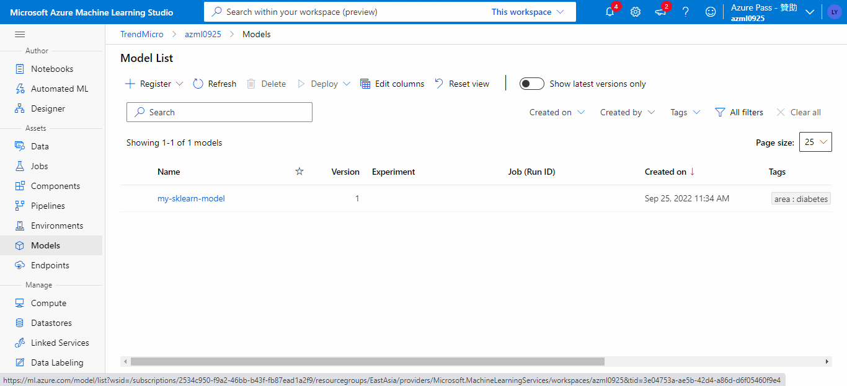

建置PY檔案可以讓API呼叫

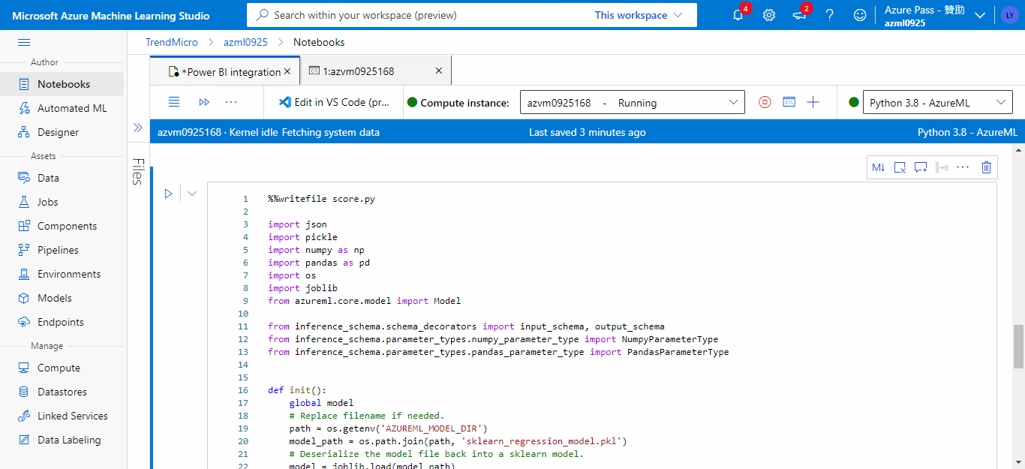

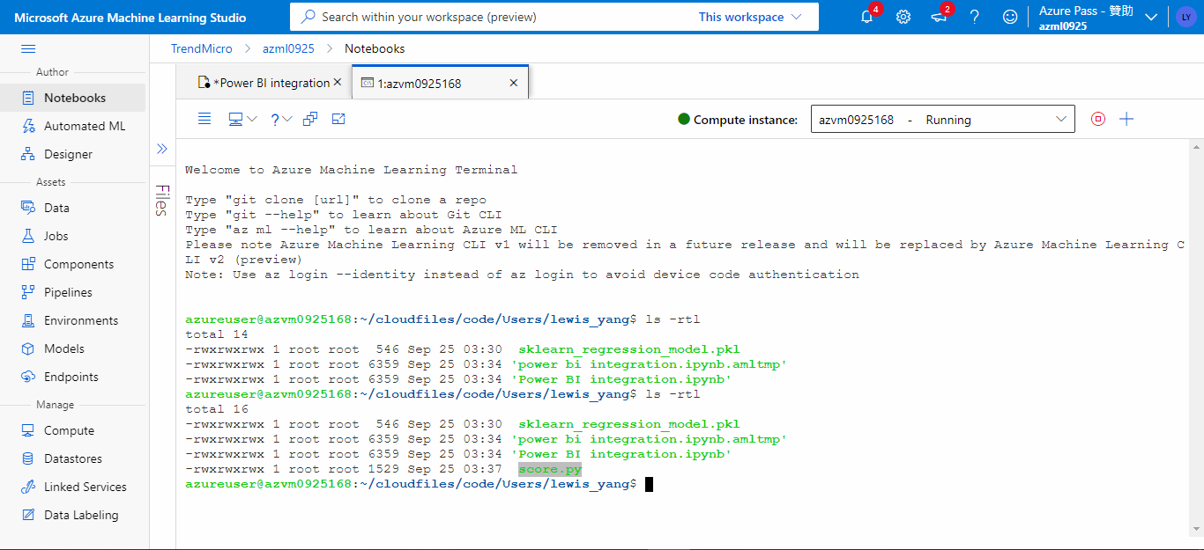

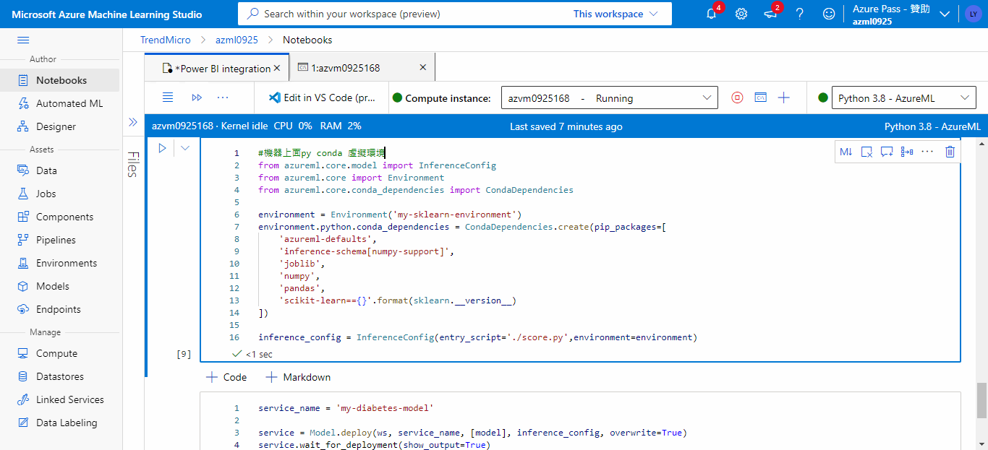

建置端點API

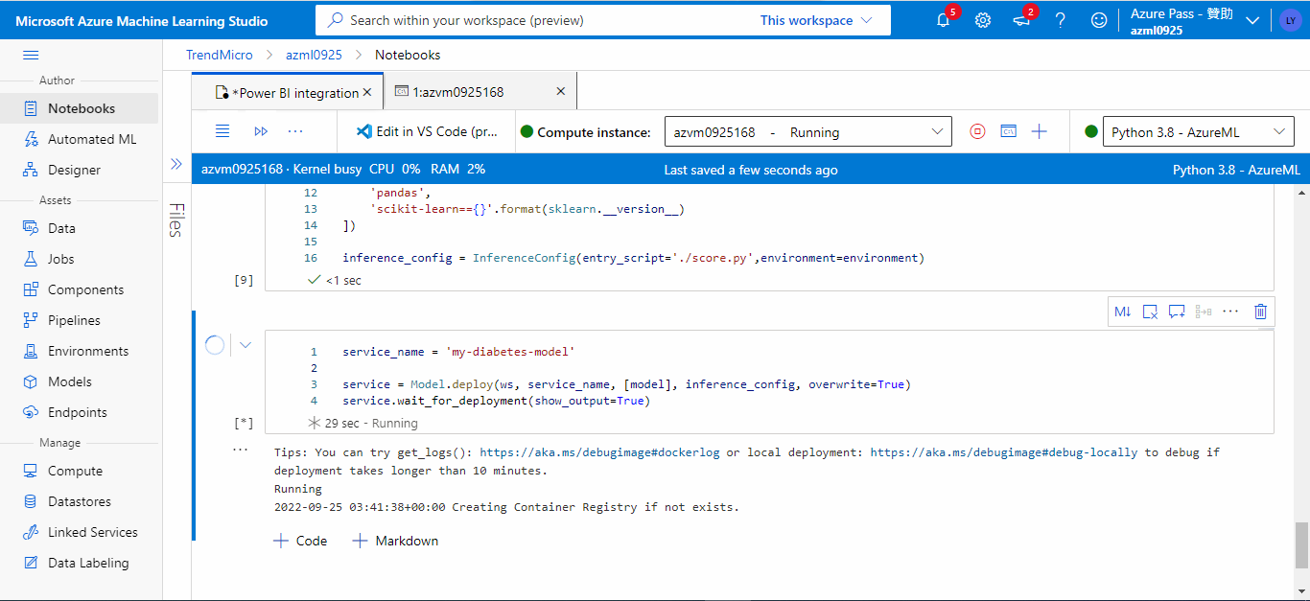

出現端點

